# Submitted in partial fulfillment of completion of the course

**Web hosting Static​ File in IBM Cloud**

# **Submitted by:**

# **Shikha Kumari**

# **Under Guidance of:**

# **Arpita Roy (Edunet)**

|  |  |  |
| --- | --- | --- |
|  |  |  |

# Year 2022-2024

# **Table of Contents:**

# Abstract

# Acknowledgement

# Introduction to Problem

# Proposed Solution

# Requirements

# 3.1Technology Stack

# 3.2 Hardware

# 3.3 Software

# 3.4 Deployment Environment

# 4. User Requirements

# 5. Design Documentation

# 6. Implementation Details

# 7. Deployment

# 8. Conclusion

# Appendix A Project Code

# References

# **ABSTRACT:**

Hosting a static website on IBM Cloud Object Storage starts with creating a bucket and configuring it for public access.

Then, upload your website content to your bucket. Create a storage instance, upload files to a bucket, note API key and endpoint.

Deploy a simple web app on IBM Cloud Foundry with the static file build pack.

# **Acknowledgement:**

I am Shikha Kumari this is my portfolio hosted on IBM cloud are thankful to our teacher, MS. Arpita Roy for her

guidance and supervision which has provided a lot of resources needed in completing our project.

**INTRODUCTION TO PROBLEM**

Host static files on IBM Cloud using IBM Cloud Object Storage.

Create a storage instance, upload files to a bucket, note API key and endpoint.

Deploy a simple web app on IBM Cloud Foundry with the static file build pack.

This can help protect against outages, safeguard against data loss, and help support disaster recovery strategies.

**PROPOSED SOLUTION:**

1. User-Friendly Experience
2. Realtime Updates: Provide real time notifications to donors and recipients about the status of their donations and requests, including pickup or delivery schedules.
3. Mobile Responsiveness: Develop a responsive design to make the website accessible on smartphones and tablets, enabling users to access the platform from various devices.
4. Hosting static files on IBM Cloud ensures fast, reliable, and globally accessible content delivery, enhancing user experience, and optimizing web application performance.
5. It provides a scalable solution with robust storage infrastructure, benefiting developers and businesses in delivering content seamlessly to end-users. ​

# **REQUIREMENT**

# **1.Technology Stack:**

# HTML, CSS, JAVASCRIPT

# Responsive design (CSS & Bootstrap)

# **2.Hardware Requirements:**

# Processor: Intel(R) Core (TM) i5-9500 CPU @ 3.00GHz 3.00 GHz

# Installed RAM 8.00 GB (7.81 GB usable)

# System type 64-bit operating system, x64-based processor

# **3.Software Requirements:**

IBM CLOUD COMPUTING: cloud object storage BY single website hosting.

# **4.Deployment Environment:**

Web server: cloud object storage BY single website hosting.

# **User Requirements:**

* Mobile Accessibility or PCs
* Internet Access
* Supported Browser

# **Design Documentation:**



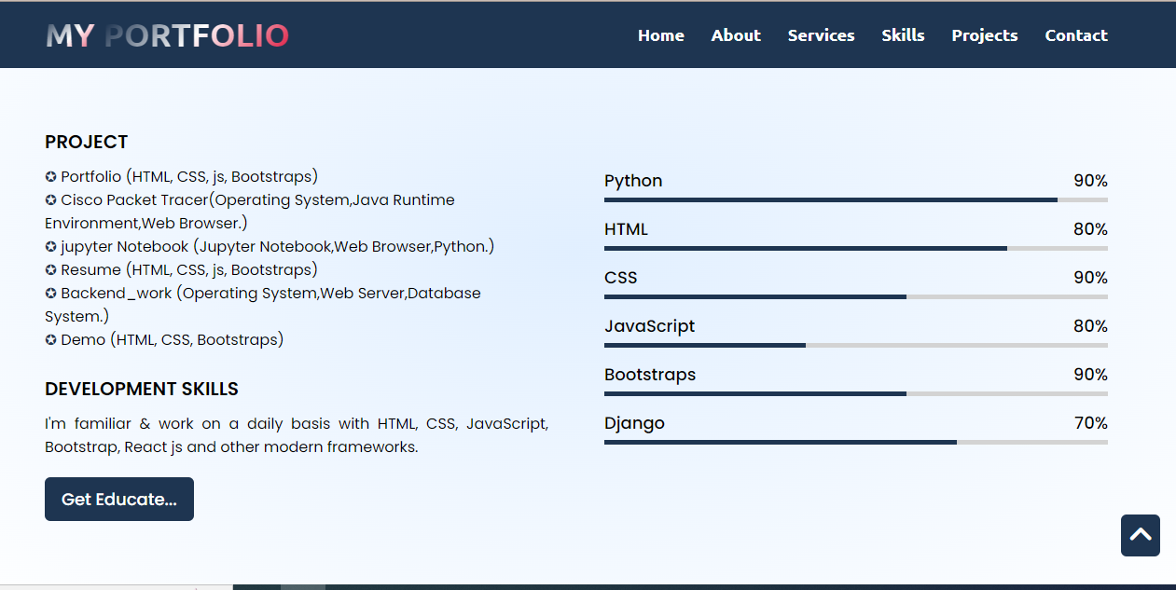

****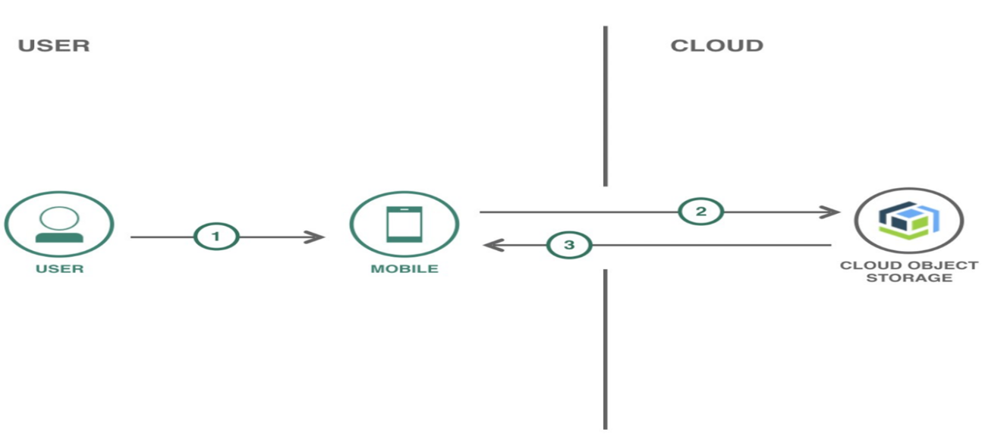

**Implementation Details:**

Mobile-Friendly Design: Ensure that your platform is responsive and mobile-friendly, as many users

# Scalability: Use cloud services like IBM Cloud for scalability.

Implementation Single website host: we create Single website host for user -friendly. It developed by IBM cloud object storage. creating a bucket and configuring it for public access.

It provides a scalable solution with robust storage infrastructure, benefiting developers and businesses in delivering content seamlessly to end-users. ​

# **DEPLOYMENT:**

Implementation Single website host: we create Single website host for user -friendly. It developed by IBM cloud object storage. creating a bucket and configuring it for public access.

# Security: - Apply strong security measures to protect user data, including information.

**CONCLUSION**

Hosting static files on IBM Cloud ensures fast, reliable, and globally accessible content delivery, enhancing user experience, and optimizing web application performance.

​ To host a static file portfolio on IBM Cloud, you can follow these general steps:

Create a Cloud Object Storage (COS) Instance:

Log in to your IBM Cloud account.

Navigate to the IBM Cloud dashboard.

Create a new Cloud Object Storage instance.

Upload Your Static Files:

Once your COS instance is set up, upload your static files (HTML, CSS, images, etc.) to a bucket in COS. This is where your files will be stored.

Configure COS Bucket for Static Website Hosting:

In the COS dashboard, find the bucket containing your static files.

Enable static website hosting for that bucket and configure the main page and error page.

Access Your Static Website:

 After setting up static website hosting, you'll be provided with a URL to access your static files. 

**APPENDIX:**

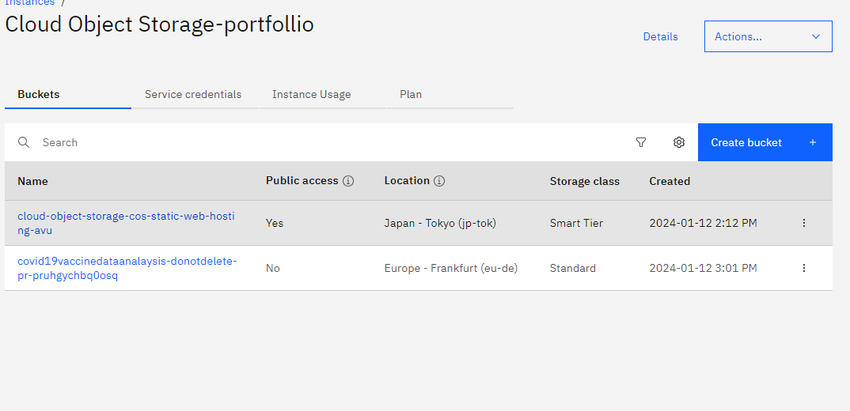

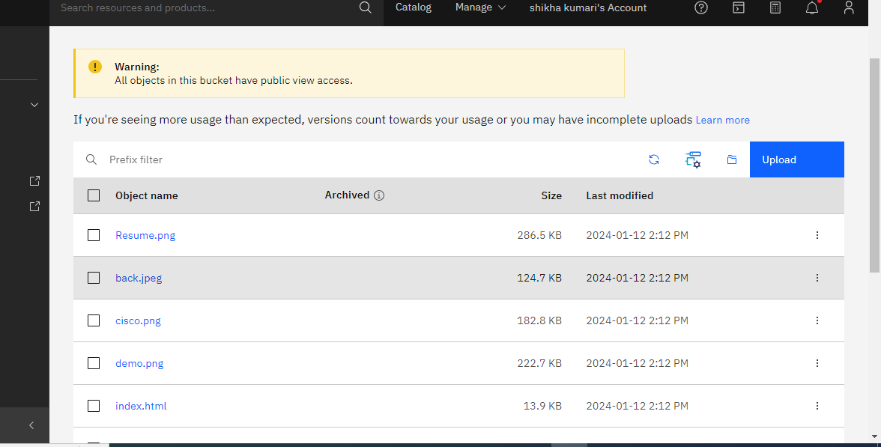

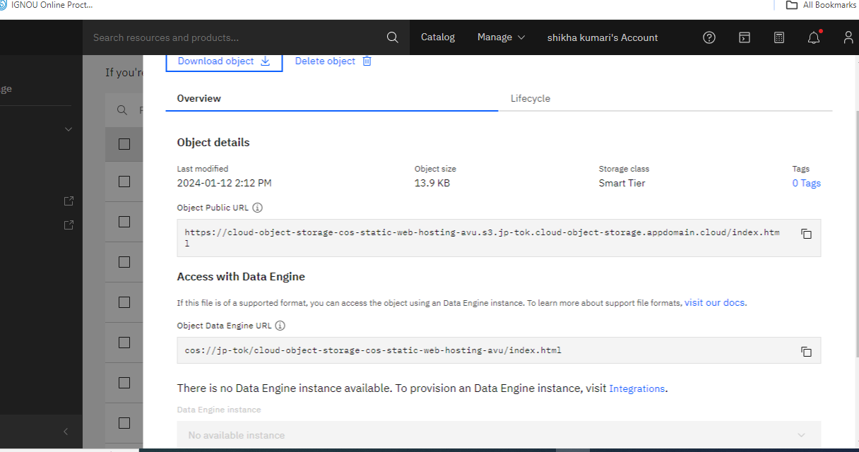





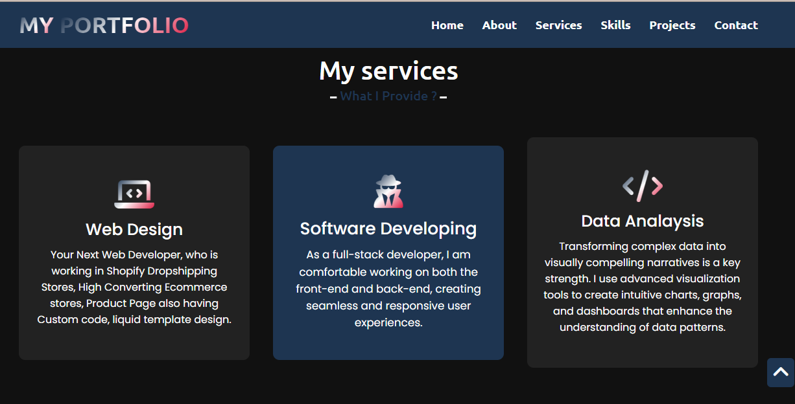



**References: -**

https://cloud-object-storage-cos-static-web-hosting-avu.s3.jp-tok.cloud-object-storage.appdomain.cloud/index.html